Biodiversity: Diversity in a Leaf Pack
STUDENT PAGES

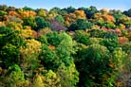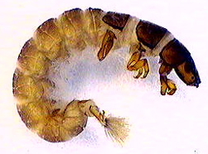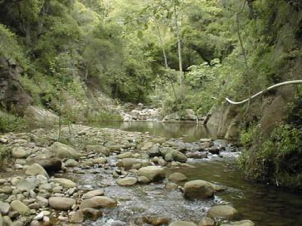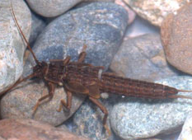

Written by: Jennifer Doherty and Cornelia Harris
With assistance from Andy Anderson, Marcia Angle, Mitch Burke, Terry Grant, Laurel Hartley, Michele Johnson, Shawna McMahon, John Moore, Liz Ratashak, Michael Schiebout, Jonathon Schramm, Scott Simon, Lori Spindler, Brook Wilke
Culturally relevant ecology, learning progressions and environmental literacy
Long Term Ecological Research Math Science Partnership
September 29, 2010

Disclaimer: This research is supported by a grant from the National Science Foundation: Targeted Partnership: Culturally relevant ecology, learning progressions and environmental literacy (NSF-0832173). Any opinions, findings, and conclusions or recommendations expressed in this material are those of the author(s) and do not necessarily reflect the views of the National Science Foundation.

Table of Contents
Stream Characteristics Data Sheet 3
Stream Characteristics Physical Habitat Data Sheet 4
Macroinvertebrate Data Collection 7
How are organisms related? 9
Who eats whom? 10
How are organisms related? Revisited 12
What size is it? 13
Who eats whom? Revisited 14
Comparing the stream to what is familiar 17
What affects what lives in leaf packs? 18

Stream Characteristics Data Sheet

Date
 | Pool #1 | Riffle #1 | Pool #2 | Riffle #2
Water temperature

Dissolved Oxygen

pH

Stream Velocity

Other:

Stream Characteristics Physical Habitat Data Sheet
Measure a 10m segment of your stream to collect the following measurements:
Stream width:
Measure the stream at three different spots along your length and find an average: _________
Water appearance/odor:
___ clear ____ clear-brown _____ milky _____ greenish
___ foamy ____ muddy _____ multi-color _____ other (describe)
Stream velocity:
Step 1: Stream segment width
Find the average width of your stream segment at the top, middle, and bottom end of your segment.
Width top: _______
Width middle: ______
Width bottom: ______
Average: ______ m
Step 2: Stream segment velocity
Using your segment, drop a ping pong ball or a tennis ball (depending on the perceived velocity of your stream-a ping pong ball works better in slower moving water) and record the speed at which the object travels the length of the segment. You should do this at the left, middle, and right side of the stream, and then average your measurements.

Left side (sec) | Middle (sec) | Right side (sec) | Average
Average of all three segments (time in seconds)

Step 3: Stream depth. Stretch a tape measure across the stream at the mid-point of your stream segment. At 1 m intervals across the stream, measure the depth (in m) and record it in the table below. If you have a very wide stream, measure depth every 2 or 3m.
Distance (m) | Depth |  | Distance (m) | Depth
0 | 0 |  | 6
1 |  |  | 7
2 |  |  | 8
3 |  |  | 9
4 |  |  | 10
5 |  |  | 11

Sum of depths: ______ / number of samples taken = _________ average depth of stream

Step 4: Flow calculation
Now that you have all your measurements, simply plug in the numbers in the equation:

[10m (length) x _____ m (width) x _____ m (depth)] ÷ _____ (time secs) = _____ cubic meters/sec

Habitat:
 | Many | Some | Few/none
Riffles (fast areas, <2 feet deep)
Runs (fast areas, >2’ deep)
Pools (slow areas, >2’ deep)
Glides (slow areas, <2’deep)
Shelter for fish (logs, stumps etc)
Patches of aquatic plants

Substrate size: Rank the substrate sizes from most common (1) to least common (6)
Silt/clay/sand | Sand (0.06mm-2mm) | Gravel (2mm-64mm) | Cobbles (64mm-250mm) | Boulders (250mm-4000mm) | Bedrock (solid rock covering bottom)

Cobble Embeddedness: Pick up several cobbles (if present) to estimate the average embeddedness of your site.
Average embeddedness: _______ % 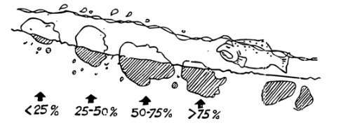
Image from Hudson Basin River Watch Guidance Document
Stream banks:
 | In no or few areas | In some areas | In many areas
Covered with vegetation
Eroding
Mowed
Artificially protected

Human Impacts and Land Use:
___ stream channel altered ___ farms ___ industry
___ storm drain pipes ___ recreation ___ housing
___ sewage treatment plant pipes ___ garbage ___ logging
___ dams ___ mining ___ roads

Other: ____________________________
For more in-depth survey guidelines, see Behar, S. and M. Cheo. 2004. “Hudson Basin River Watch Guidance Document.”

Macroinvertebrate Data Collection
Names in group: Place in stream (riffle or pool): Type of leaves: Stream Name: State:

- First, before you empty your bags out, observe how the litter looks (is it green, brown, decaying, in clumps, etc.). Carefully explore in and around the leaves. Do you see any organisms? Are any of them together? What parts of the leaf pack are the organisms in or on?
- Empty the bag of leaf litter according to your teacher’s instructions. Separate the animals you find into major groups using the key, sorting mat and Petri dishes provided.
- Now, count the numbers of invertebrates in each Petri dish on your sorting mat and record your data in the table on the next page. Take notes about relative sizes and any other things you noticed about the invertebrates in your leaf pack. Only fill out the Number and Notes columns today. You will keep this sheet and fill out the other columns later in this unit.
Example
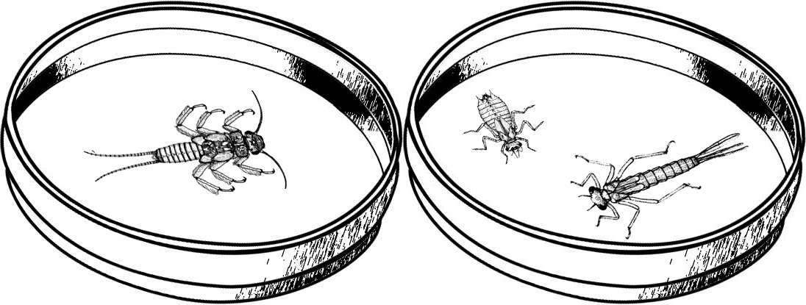
Major Groups  Common name (Order) | Number of individuals | Notes
Stoneflies (Order Plecoptera) | 1 | Seen eating a smaller invert
Dragonflies and Damselflies (Order Odonata) | 2 | Sizes: One big with skinny tail and one small with fat tail
Questions to think about while you are sorting your organisms:
How can you tell when organisms are different kinds?

How are the organisms different from one another?

Do you think all of these organisms eat the same thing? Why or why not?

Major Groups  Common name (Order) | Number of individuals | Notes | Kingdom | Phylum | Sub-  phylum | Feeding Group | Dissolved oxygen needs (mg/L)
Stoneflies (Order Plecoptera) |  |  | Animalia | Arthropoda | Hexapoda | Mostly Predators | 8-12
Dragonflies and Damselflies (Order Odonata)
Mayflies (Order Ephemeroptera)
Major Groups  Common name (Scientific classification | Number of individuals | Notes | Kingdom | Phylum | Sub-  phylum | Feeding Group | Dissolved oxygen needs (mg/L)
Water Beetles (Order Coleoptera)
True Flies (Order Diptera)
Crane Flies(Order Diptera, Family Tipulidae)
Dobsonflies and Alderflies (Order Megaloptera)
Caddisflies (Order Tricoptera)
Net-spinner Caddisflies (Order Tricoptera, Family Hydropsychidae)
Water mites (Order Acari)
Springtails (Subclass Collembola)
Scuds (Order Amphipoda)
Sowbugs (Order Isopoda)
Crayfish (Order Decapoda)
Snails (Class Gastropoda)
Clams and Mussels (Class Bivalvia)
Leeches (Subclass Hirudinea)
Aquatic Earthworms (Subclass Oligochaeta)
Planaria (Class Turbellaria)
Nematodes

How are organisms related?

Use the group names and characteristics on the Classification Poster to classify the macroinvertebrates you found in your leaf pack. Put each card in the appropriate box. Record the name of the Kingdom, Phylum, and subgroup on your Macroinvertebrate Data Collection worksheet.

Data Analysis
- How many different Orders of organisms did you find in your pack?
Are all of the organisms in each Order exactly the same?

- In what ways are organisms in an order the same?

- In what ways are organisms in an order different?

- How many different Phyla of organisms did you find in your pack?

- In what ways are organisms in a Phylum the same?

- In what ways are organisms in a Phylum different?

- How many different Kingdoms of organisms did you find in your pack?

- In what ways are organisms in these Kingdoms different from one another?

Who eats whom?
- Why do organisms eat?

- What do each of the following types of organisms eat?
  - Predators:

  - Scrapers:

  - Shredders:

  - Collectors:

- Do all organisms in a feeding group have the same dissolved oxygen requirements?

- Check your food web diagram. Did you diagram the way each of the organisms in your food web gets their food?

- In which type of feeding group did you find the greatest number of organisms?
Why do you think that is?

- Are there any feeding groups described in the Stream Invertebrate Biology Briefs that you did not find in your sample? Why do you think that might be?

- Pick one group of organisms that you found in the stream (ex: mayflies):
What feeding group is your group in?
Use your food web drawing to predict what you think would happen to the other organisms found in the leaf pack if your chosen group of organisms did not exist in the stream?

- Complete the table below. Hint: The key is to think about what the food does when it is in the environment.
Feeding Group | What organism does this group eat? How does it get its food? | How will a decrease in that food affect the abiotic environment?
Scrapers
Collectors
Shredders

How are organisms related? Revisited

- Using the classification poster and organism cards, classify the microscopic organisms. Are all microscopic organisms in the same Kingdom?

- Classify the parts of the community that you didn’t sample because they were outside your leaf pack, but still impact the community in your leaf pack. Why do you think they were not in the leaf pack?

- Why do you think those things impact your leaf pack community even though you didn’t see them?

- How many different Kingdoms of organisms are interacting in this stream ecosystem (including the ones you did not sample)?

- In what ways are these kingdoms the same?

- In what ways are these kingdoms different?

What size is it?
Using your Macroinvertebrate Data Collection worksheet copy the names of some of the organisms you identified in your leaf pack. Using the Powers of Ten chart and the Organism Cards, decide what size each of these organisms are. Then record the size in the chart below and decide if each item is living or non-living, and what each thing is made of.
Name of item |  | Size |  |  | Is it Living or  Non-living? |  | What is it made of?  atoms and/or  molecules and/or  a single cell and/or  multiple cells
Microorganisms
1
2
3
4
5
6
Macroinvertebrates
1
2
3
4
5
6
7
8
9
Other organisms
1
2
3
4
Matter in water
Organic matter
Nitrate molecules
Phosphorus molecules
Oxygen molecules
Water molecules

- What is a mature Oak tree made of? Start with the visual parts of the tree that you can see and finish with the smallest particles you can trace.

- Is there Carbon in an Oak tree? Nitrogen? Oxygen? Phosphorus? How do we know?

Who eats whom? Revisited

- How do each of the following types of organisms get food?
  - Producers:

  - Decomposers:

  - Consumers:

Check your diagram. Did you diagram the way each of the organisms in your food web gets their food?

- Is there more than one type of microscopic consumer in your pack?

Why do you think that is? Why is there not just one best type of microscopic consumer?

- Complete the table below. Hint: The key is to think about what the food does when it is in the environment.
Feeding Group | What organism does this group eat? How does it get its food? | How will a decrease in that food affect the abiotic environment? | What organism groups can be affected by this abiotic factor? | How will the change in the abiotic factor affect this group?
Decomposers |  |  | Producers | Producers need mineral nutrients so they might grow slower if there are less mineral nutrients in the water.
Scrapers |  |  | Any organism that has specific oxygen requirements. | It depends on how much oxygen they need.
Collectors | Bits of organic matter and small organisms floating in the water. They take the floating bits out of the water. | Bits of organic matter and small organisms floating in the water make the water cloudy. A decrease in the bits in the water will lead to the water being clearer. This will let more sunlight into the water.
Shredders |  |  | Producers.
Producers | Makes their own food using sunlight, CO₂ and water and produce O₂ and food. | When producers make food they increase the amount of oxygen in the water.
- What would happen to the abiotic environment if collectors disappeared from the stream?

- What would happen to the biotic environment if collectors disappeared from the stream?

- What would happen to the abiotic and biotic environment if there were three types of collectors and one of them disappeared from the stream?

- You have just learned how an organism can change its abiotic environment in a way that also affects the other members of biological community. Can you think of any changes to a biological community in another ecosystem that would change the abiotic environment and therefore affect the biological community?

Comparing the stream to what is familiar

- What ecosystem are you most familiar with? What makes it an ecosystem?

- Using a different color marker, update your group’s familiar food web. Can you add more organisms or details about relationships now that you have studied the stream ecosystem?

- What parts of your familiar ecosystem would you want to know more about in order to make a more complete food web? In other words, what parts might be missing but you’d need to find out more to add?

- Are there the same types of feeding groups in each ecosystem?

- If not, are there equivalent groups?

- Can you think of any changes in the biological community of your familiar ecosystem that would change the abiotic environment of the ecosystem?

- Would these changes affect the biological community? How?

What affects what lives in leaf packs?
- Calculate the average number of individuals in each macroinvertebrate group using the data collected in the whole class. Do this separately for the leaf packs in the riffles and in the pool. Why are you averaging the data from the different places in the stream separately?

- Create a bar graph comparing the number of individuals in each group from the two types of packs, riffles and pool, using the graphing handout provided by your teacher.

- Using the averages from your class data, how many groups did your class find in:
  - Leaf packs in riffles had _______ groups.
  - Leaf packs in pools had _______ groups.
  - Richness tells us how many different groups of organisms are in an ecosystem. Based on this information, which leaf packs had the greatest richness of macroinvertebrate groups?

Riffles Pools

- Look at the following example:

Tree Type | Habitat A (No. of ind.) | Habitat B (No. of ind.)
Pines | 220 | 900
Oaks | 300 | 50
Maples | 380 | 50
Using the example table, what is the richness in each habitat? A: B:

- Evenness tells us how evenly the different groups of organisms are distributed in an ecosystem, or the relative abundance of each group in an area. Using the example table, which habitat has greater evenness?

- Look the graphs of your data. How “even” were the communities you found in your packs? That is, did you have similar numbers of organisms in each of the different groups that you found or did you have many more in some groups than others?

- Do you think it matters if a community is more even or less even?
Why?

- Using the data your teacher provides, describe any differences in abiotic resources or conditions between the riffles or pools in-

-the amount of dissolved oxygen:

-the pH of the water:

-the temperature of the water:

Other characteristics:

- Using the graphs you made in question 2, describe any major differences in the groups of invertebrates you found in leafs packs in the riffles and pools.

- Why might the groups that you found in the leaf packs be different? You may want to use your answer to question number 8 and your Macroinvertebrate Data Collection table to help you answer this question.

- Besides the abiotic factors you measured, what else could have influenced the diversity of the organisms you found in the two types of leaf packs?

- Are there the same of feeding groups in both types of leaf packs?

- Are the members of each feeding group exactly the same in both types of leaf packs?

Why do you think that is?

- There were probably multiple kinds of collectors or predators living in your leaf packs. Why do you think there are multiple kinds of collectors or predators instead of one best collector?

- A thought experiment: If you took a bunch of invertebrates from a stream in New York and put them in a stream in California, what do you think would happen? Explain why. Give as many reasons as you can.

- What additional information would you need to know to feel more confident in your answer?

